**Class:** Final Year (Computer Science and Engineering)

**Year:** 2022-23 **Semester:** 1

**Course:** High Performance Computing Lab

**PRN: 2019BTECS00063**

**Practical No. 11**

**Problem Statement 1:**

Execute the MPI program (Program A) with a fixed size broadcast. Plot the performance of the broadcast with varying numbers of processes (with constant message size). Explain the performance observed.

**CODE:**

#include <stdio.h>

#include <stdlib.h>

#include <time.h>

#include <mpi.h>

*int* main(*int* argc, *char* *argv[]) {

    // if (argc != 2) {

    //     printf("Usage : bcast message_size\n");

    //     return 1;

    // }

*int* rank;

*int* size = atoi(argv[1]);

*char* buffer[size];

    MPI_Init(&argc, &argv);

    MPI_Comm_rank(MPI_COMM_WORLD, &rank);

*int* i;

    if (rank == 0) {

        srand(time(NULL));

        for (i = 0; i < size; i++)

        buffer[i] = rand() % 256;

    }

*double* total_time = 0.0;

*double* start_time = 0.0;

    for (i = 0; i < 100; i++) {

        MPI_Barrier(MPI_COMM_WORLD);

        start_time = MPI_Wtime();

        MPI_Bcast(buffer,size,MPI_CHAR,0,MPI_COMM_WORLD);

        MPI_Barrier(MPI_COMM_WORLD);

        total_time += (MPI_Wtime() - start_time);

    }

    if (rank == 0) {

        printf("Average time for broadcast : %f secs\n", total_time/100);

    }

    MPI_Finalize();

}

**OUTPUT:**

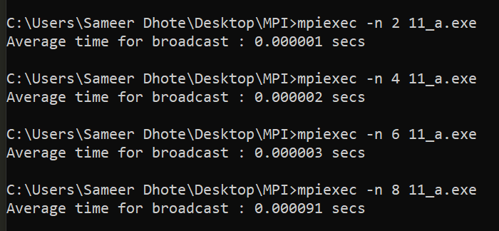

**Problem Statement 2:**

Repeat problem 2 above with varying message sizes for reduction (Program B). Explain the observed performance of the reduction operation.

**CODE:**

#include <stdio.h>

#include <stdlib.h>

#include <time.h>

#include <mpi.h>

*int* main(*int* argc, *char* *argv[]) {

    // if (argc != 2) {

    //     printf("Usage : reduce message_size\n");

    //     return 1;

    // }

*int* rank;

*int* size = atoi(argv[1]);

*char* input_buffer[size];

*char* output_buffer[size];

    MPI_Init(&argc, &argv);

    MPI_Comm_rank(MPI_COMM_WORLD, &rank);

*int* i;

    srand(time(NULL));

    for (i = 0; i < size; i++)

        input_buffer[i] = rand() % 256;

*double* total_time = 0.0;

*double* start_time = 0.0;

        for (i = 0; i < 100; i++) {

            MPI_Barrier(MPI_COMM_WORLD);

            start_time = MPI_Wtime();

            MPI_Reduce(input_buffer,output_buffer,size,MPI_BYTE,MPI_BOR,0,MPI_COMM_WORLD);

            MPI_Barrier(MPI_COMM_WORLD);

            total_time += (MPI_Wtime() - start_time);

        }

        if (rank == 0) {

        printf("Average time for reduce : %f secs\n", total_time/100);

    }

    MPI_Finalize();

}

**OUTPUT:**

